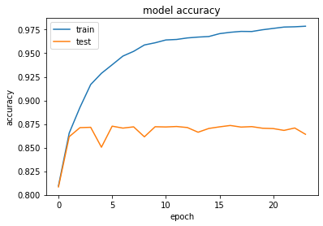

These are the graphs depicting model accuracy and model loss.

If the value is increasing the train accuracy and test accuracy are increasing . If the value is decreasing the train accuracy and test accuracy are decreasing. The graph above shows the results as described.

In the model loss graph you observe the case is different in this scenario. If the value is decreasing the train accuracy and test accuracy are increasing and the if the value increases the train accuracy and test accuracy are decreasing.

These are the observations from the code that is required and the graphs mentioned above.